Studio 9

Name and Student Id: Xin Xu 30421225

Self-Evaluation:

|  |  |  |  |  |  |
| --- | --- | --- | --- | --- | --- |
| Need Help | Work in Progress | Pass | Credit | Distinction | ***High Distinction*** |

Tutor Evaluation:

|  |  |  |  |  |  |
| --- | --- | --- | --- | --- | --- |
| Incomplete | Needs improvement | Pass | Credit | Distinction | High Distinction |

Task 9.1:

{Answers}

B. difference between .woff and .woff2 font

The Web Open Font Format (WOFF) is a font format for use in web pages. WOFF files are OpenType or TrueType fonts, with format-specific compression applied and additional XML metadata added. The two primary goals are to first distinguish font files intended for use as web fonts from fonts files intended for use in desktop applications via local installation, and second to reduce web font latency when fonts are transferred from a server to a client over a network connection.

WOFF2 is a font format that provides, which is the next generation of WOFF, on average, a 30% reduction in file size, thus helping Web fonts load more quickly in compatible browsers.

{Screenshots}

A screenshot of demonstration of using Responsive Images

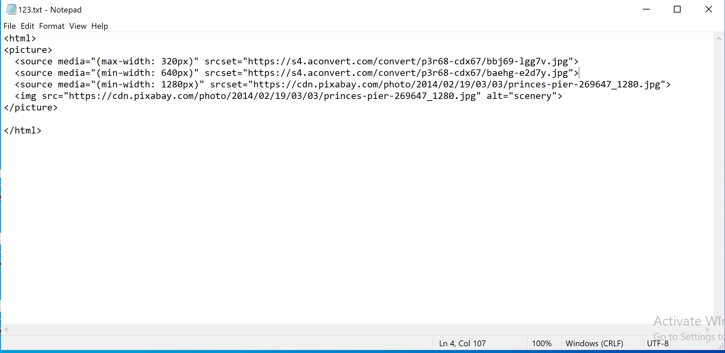

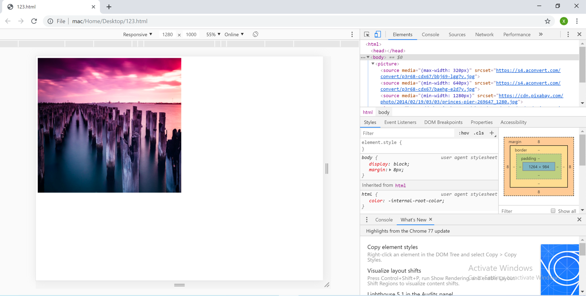

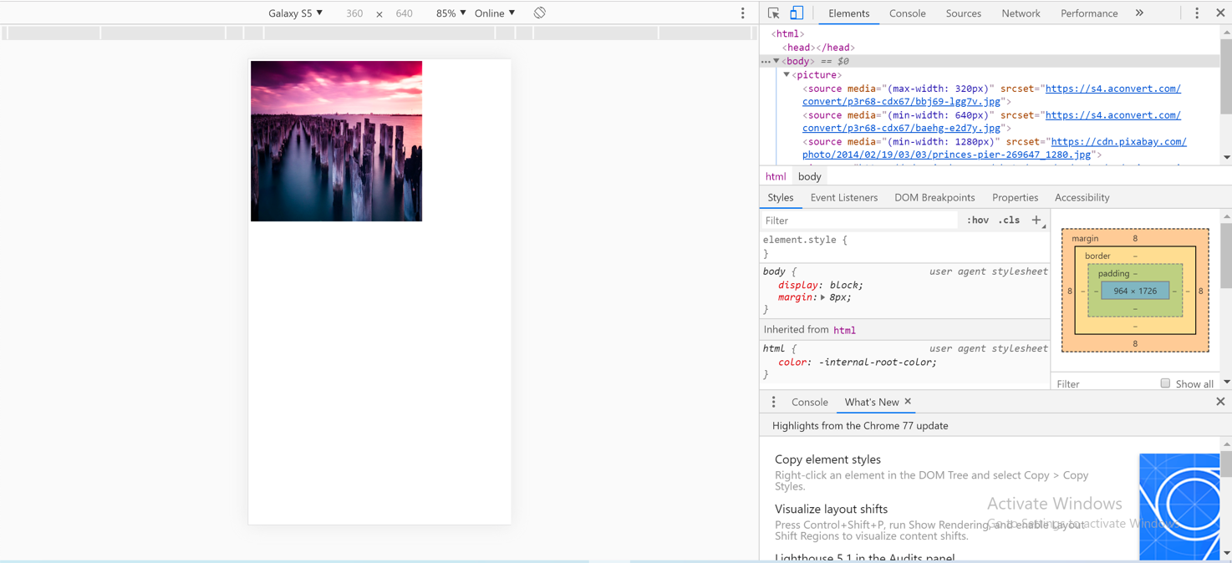

{Link to code repository}

{References}

https://creativemarket.com/blog/the-missing-guide-to-font-formats

{URLs}

https://drive.google.com/drive/u/1/folders/1EJm0eM0xhxAZXouHovffv0YsfZgxz1be

Task 9.2:

{Answers}

A. new feature of .NET Core

1. Cross-platform Functionality

When targeting Mac OS, Linux or Unix systems, the .NET Core stands out as the best choice. Developers can now deploy the latest technologies like Docker, Microsoft Azure, Kubernetes and others with ASP.Net Core. The .NET Core SDK offers many command-line tools that help create, compile, build, and publish a .NET Core application on any OS.

2. Unification of Development Models

The MVC and Web API development models are unified and use the same base class Controller. It allows a controller to expose HTML (View) and Web Service features. The MVC model of ASP.NET Core provides functionality for creating web APIs and web applications that are testable. Further, built-in support for multiple data formats and content negotiation allows your web APIs applicable across a wide range of platforms, including browsers and mobile devices.

3. SignalR Java Client

Another ASP.NET Core latest feature includes the addition of a Java client for SignalR. It is a library for ASP.NET that allows server code to send asynchronous notifications to client-side web applications. As for the Java client that is added, as it supports connection to the SignalR Server from Java code, including Android apps.

B. difference with .NET framework

1. open source

NET Framework was releases as a licensed and proprietary software framework while .NET Core is an open source software framework. Hence, both enterprise and individual developers can build apps with .NET Core without paying any licensing fees.

2. cross-platform

.NET Framework enabled developers to build applications for a single platform — Windows. But .NET Core is cross-platform, and supports three distinct operating systems — Windows, OS X, and Linux. Therefore, it is easy to build cross-platform application and port existing applications from one platform to another.

3. cloud services

Unlike .NET Framework, .NET Core is designed with features to simplify development and deployment of cloud-based application. The developers can use ASP.NET to build a variety of cloud-based applications rapidly.

{Screenshots}

{Link to code repository}

{References}

https://medium.com/@mindfiresolutions.usa/difference-between-net-core-and-net-framework-c0588e734b99

https://www.rishabhsoft.com/blog/asp.net-core-features

https://www.amarinfotech.com/difference-between-net-core-2-0-vs-net-framework.html

{URLs}